Requirement Specification For LIBRARY MANAGEMENT

Version: 0.1

Hanoi, May 2023

Revision History
Date | Version | Author | Change Description
22/04/2023 | 01 | Group 4 | Create SRS for Library Management

TABLE OF CONTENTS

Contents
TABLE OF CONTENTS 2
1. Introduction 2
1.1 Purpose 2
1.2 Overview 2
1.3 Intended Audience and Reading Suggestions 3
1.4 Abbreviations 4
1.5 References 4
2. High Level Requirements 5
2.1 Entity Relationship Diagram 5
2.2 Workflow 7
2.2.1 Class Management 7
2.2.2 Candidate Management 9
2.2.3 Trainee Management 9
2.3 State Transition Diagram 10
2.3.1 Class Management 10
2.3.2 Candidate Management 12
2.3.3 Trainee Management 12
2.4 Use Case Diagram 12
2.4.2 Candidate Management 15
2.4.4 Trainer Management 18
2.5 Permission Matrix 20
3. Use Case Specifications 23
3.1 General 23
3.1.1 UC1: Log in 23
Activities Flows 24
Business Rules 24
3.1.2 UC 2: Logout 25
Activities Flows 26
Business Rules 26
3.2 Class Management 26
3.2.1 UC3: Create a new Class 26
3.2.2 UC4: Update an existing Class 30
3.2.8 UC 10: Remove Trainee from Class 47
Activities Flows 68
3.2.18 UC 20: Update Status in Class of Trainee in a Class 70
3.2.19 UC 21: Update Attendance Status of Trainee(s) in a Class 72
3.2.20 UC 22: Update Topic Mark of Trainee(s) in a Class 75
3.2.21 UC 23: Update Reward and Penalty of Trainee(s) in a Class 79
3.2.22 UC 24: Update Allocation of Trainee(s) in a Class 82
3.3 Candidate Management 85
3.3.1 UC 25: Create a new Candidate Profile 85
3.3.2 UC 26: Update an existing Candidate 88
3.3.3 UC 27: Delete an existing Candidate 91
3.3.4 UC 28: View an existing Candidate 93
3.3.5 UC 29: Transfer Candidate 94
3.4 Trainee Management 96
3.4.1 UC 30: Update Trainee Profile 96
3.4.2 UC 31: View Trainee Profile 101
3.4.3 UC 32: Delete Trainee Profile 102
3.4.4 UC 33: Calculate Disciplinary Point 105
3.4.5 UC 34: Calculate Committed Working Duration 106
3.4.6 UC 35: Calculate Allowance 107
3.5 Common Business Rules 109
4. Mockups Screen 109
4.1 General 109
4.1.1 Log in 109
4.1.2 Landing Page - TBU This is Landing Page. 111
4.2 Class Management 114
4.2.1 Class listing 114
4.2.2 Information Tab – create & edit mode This screen is to create a new Class. 119
4.2.3 Information Tab – view mode 121
4.2.4 Trainee Tab – view mode 133
4.2.6 Trainee Tab – Add Trainee 143
4.3 Candidate Management 160
4.3.1 Candidate Listing 160
4.3.2 Candidate Profile – Create mode 164
4.3.3 Candidate Profile – View Candidate Information This screen is used to view a Candidate Profile. 166
4.3.4 Candidate Profile – Update Candidate Information 168
4.3.5 Candidate Profile – View result 174
4.3.6 Candidate Profile – Update Result 175
4.4 Trainee Management 178
4.4.1 Trainee Listing 178
4.4.3 Trainee Profile – Update Trainee Information 183
4.4.4 Trainee Profile – Update Training Result 190
4.4.5 Trainee Profile – View Training Result 193
4.4.6 Trainee Profile – Training Result – Class Listing 195
4.4.7 Trainee Profile – Training Result – Milestone Configuration 196
4.4.8 Trainee Profile – Training Result – Attendance Status 201
5. Other Requirements 218
6. Integration 218
7. Data Migration 0
7.1 Migration Scope 0
7.2 Data Mapping 0
8. Appendices 0
8.1 Messages List 0
8.2 Email Templates 3
8.2.1 ET 1: Sending email to Class Admin for assignment 3
8.2.2 ET 2: Sending email to Class Admin for change 4
8.2.3 ET 3: Sending email to Master Trainer and Trainer for class assignment 4
8.2.4 ET 4: Sending email to Class Admin, Master Trainer, Trainer for cancelled Class 4
8.2.5 ET 5: Sending email to Delivery Manager for approval 5
8.2.6 ET 6: Sending email to FA Manager after a Class is approved by Delivery Manager 5
8.2.7 ET 7: Sending email to Class Admin, Master Trainer, Trainer after a class is rejected by Delivery Manager 6
8.2.8 ET 8: Sending email to Delivery Manager, Class Admin, Master Trainer, Trainer after a class is accepted by FA Manager 6
8.2.9 ET 9: Sending email to Delivery Manager, Class Admin, Master Trainer, Trainer after a class is declined by FA Manager 6
8.2.10 ET 10: Sending email to Delivery Manager, Master Trainer, Trainer, Trainee after a class is started by Class Admin 7
8.2.11 ET 11: Sending email to Delivery Manager after a Class is finished. 7
8.2.12 ET 12: Sending email to FA Manager after a Class is closed. 7
8.2.13 ET 13: Sending email to Class Admin after a class is requested by Delivery Manager 8
8.2.14 ET 14: Sending email to Candidate and Campus to inform after Candidate is transferred to Campus 8
8.2.15 ET 15: Sending email to Candidate and FA to inform after Candidate is transferred to FA 9
8.2.16 ET 16: Sending email to Candidate and Internship to inform after Candidate is transferred to Internship 9

1. Introduction

1.1 Purpose
The Software Requirements Specification will:
- Define the scope of business objectives, business functions, and organizational units covered
- Identify the business processes that the solution must facilitate
- Facilitate a common understanding of what the functional requirements are for all parties involved,
- Establish a basis for defining the acceptance tests for the solution to confirm that what is delivered meets requirements.
The purpose of the document is to collect and analyze all assorted ideas that have come up to define the system, its requirements with respect to consumers. Also, we shall predict and sort out how we hope this product will be used in order to gain a better understanding of the project, outline concepts that may be developed later, and document ideas that are being considered, but may be discarded as the product develops.

1.2 Overview
This system is used for activities at the Library such as:
- Manage system
- Manage borrow-return activities
- Manage products
- Report business status
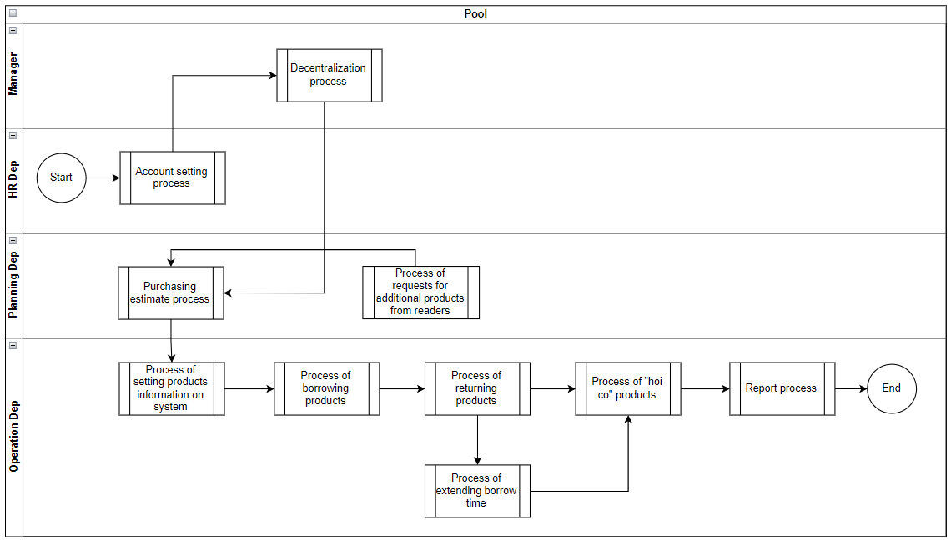
Figure 1: Actors and Roles in system

1.3 Intended Audience and Reading Suggestions
This document is intended for:
- Development team: Responsible to develop detailed design, implement and perform unit test, integration test and system test for the migrated application ❖ Data Migration team: Responsible to create data migration scripts, and perform data migration for the application.
- Documentation Team: Responsible for writing the User Guide for the application.
- UAT team: Responsible for conducting user acceptance test sessions with end users.

1.4 Abbreviations
Acronym | Reference
UC | Use Case
BR | Business Rule
CBR | Common Business Rules
Dep | Department

1.5 References
N/A

2. High Level Requirements
This section describes the general overview of the system functions or business processes which are depicted in different diagrams. It shows the types of users, their granted permissions to perform specific system functions and the sequence required to complete a business workflow (if any). As the section name implies, it is high-level which mean not detailed enough. For detailed requirement specification, please see section below.

2.1 Entity Relationship Diagram
This section graphically illustrates an information system’s entities and the relationships between those entities.
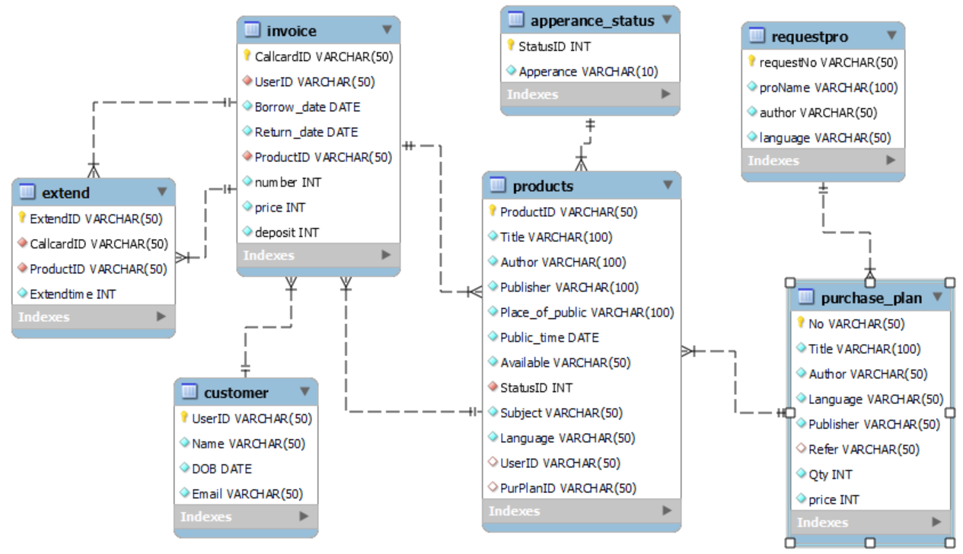
Figure 2: Entity Relationship Diagram

2.2 Business process

2.2.1 Process of borrow products
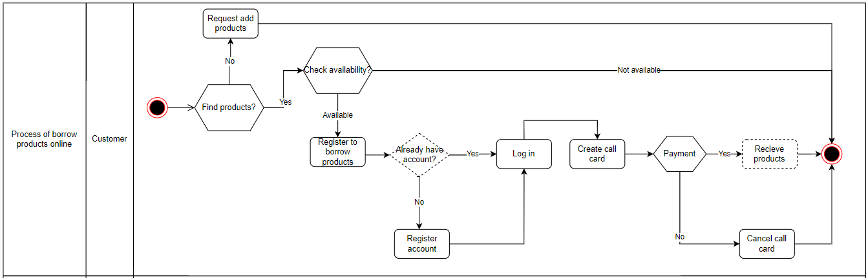
Figure : Process of borrow products online
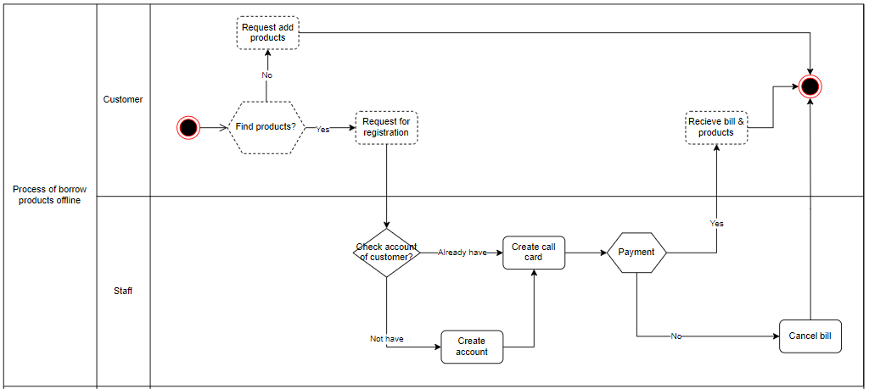

Figure : Process of borrow products offline

2.2.2 Process of return & extend time products
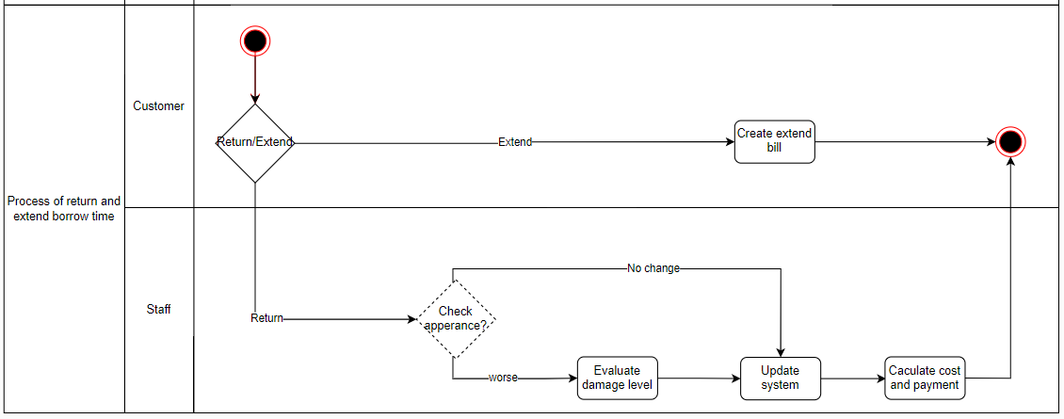

Figure : Process of return and extend borrow time

2.2.3 Process of planning for adding products
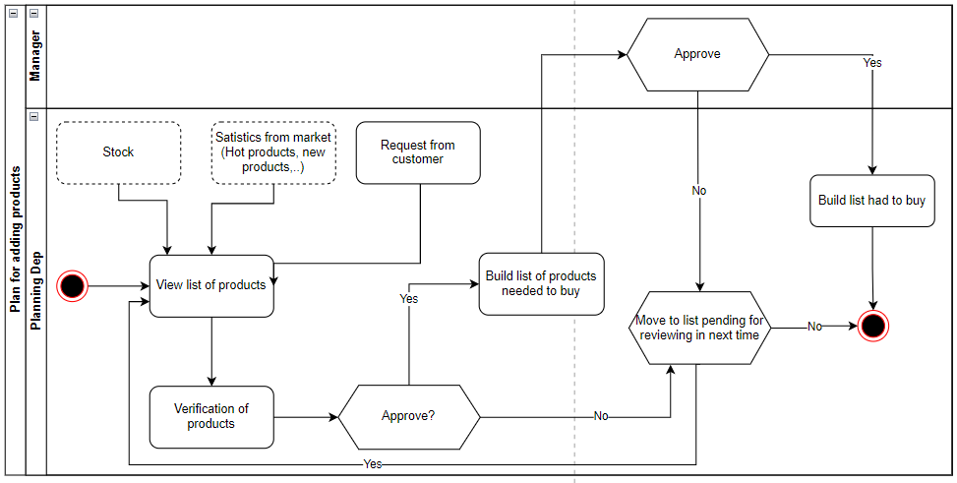
Figure : Process of planning for products needed to buy

2.2.4 Process of restore product status from unused list
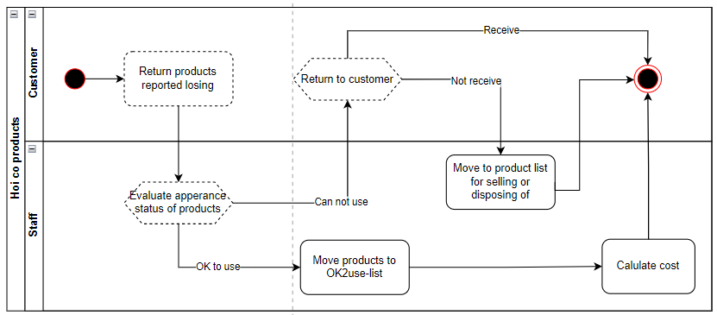
Figure : Process of restore product status

2.2.5 Process of product disposal/ liquidation/ removal

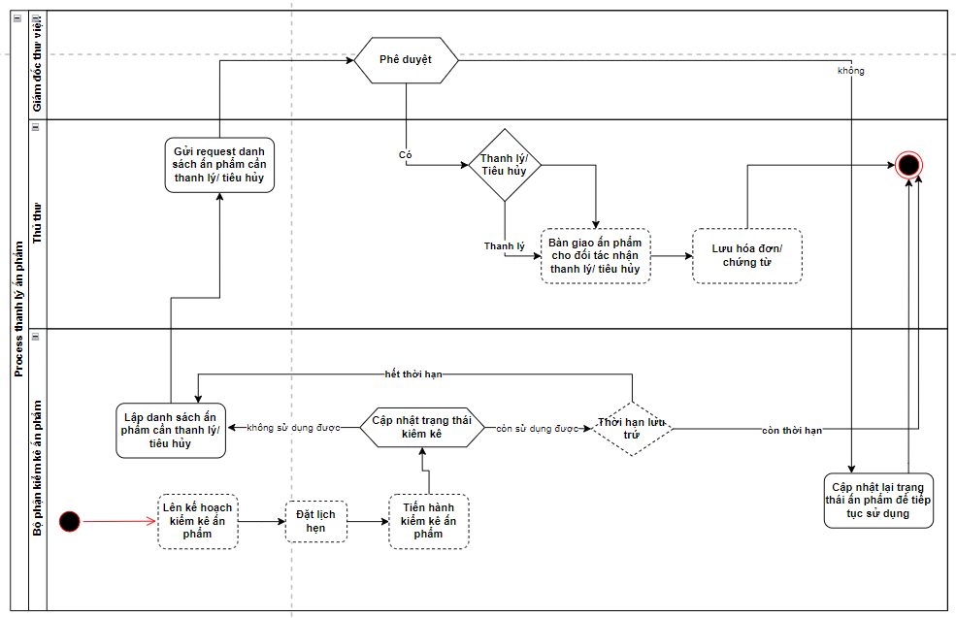

2.2.6 Process of exporting reports

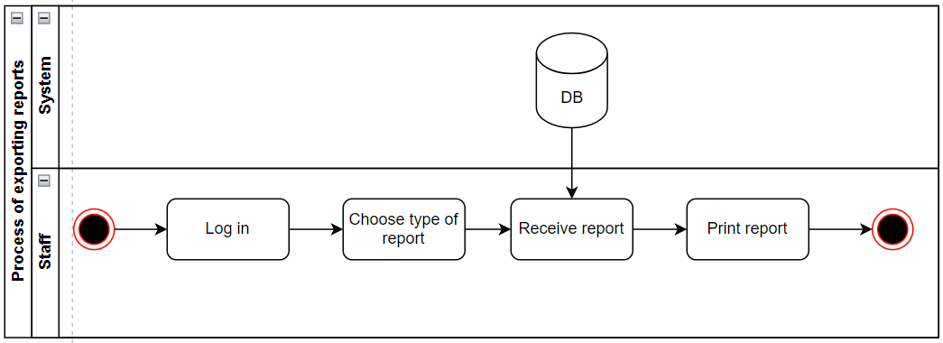
Figure : Process of exporting reports

2.4 Use Case Diagram
The use case diagram here shows the specific goal and objective or how the user interacts with the system. The eclipse in the system boundary represents the system use case/functions while the stickman represents the actor/user of the system. The line connecting the actor and the use case shows that the actor can perform that function in the system to achieve a goal.

2.4.1 Manage borrow-return-extend products
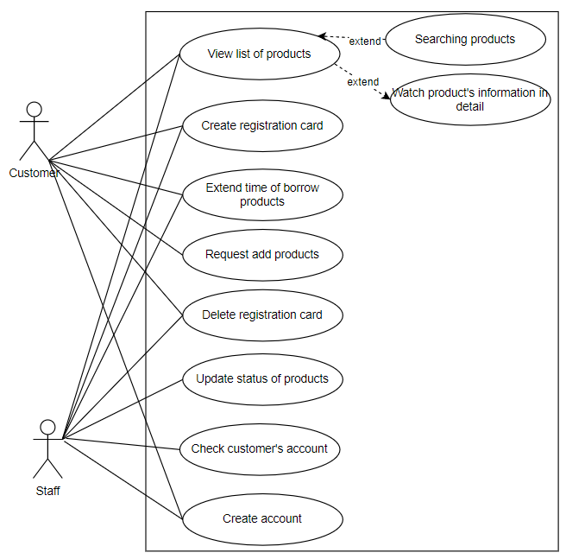
Figure : UC diagram of manage borrow-return-extend

# | UC Name | Description
1 | View list of products | This function allows customer & staff to view products
2 | Create registration card | This function allows customer & staff to create registration card
3 | Extend time of borrow products | This function allows customer & staff to extend time of borrow products
4 | Request of adding products | This function allows customers to request library adding products
5 | Delete registration card | This function allows customers to delete registration card out of their list
6 | Update status of a product | This function allows staff to update status of a product
7 | Check customer’s account status | This function allows customer & staff to check customer’s account status

2.4.2 Manage products
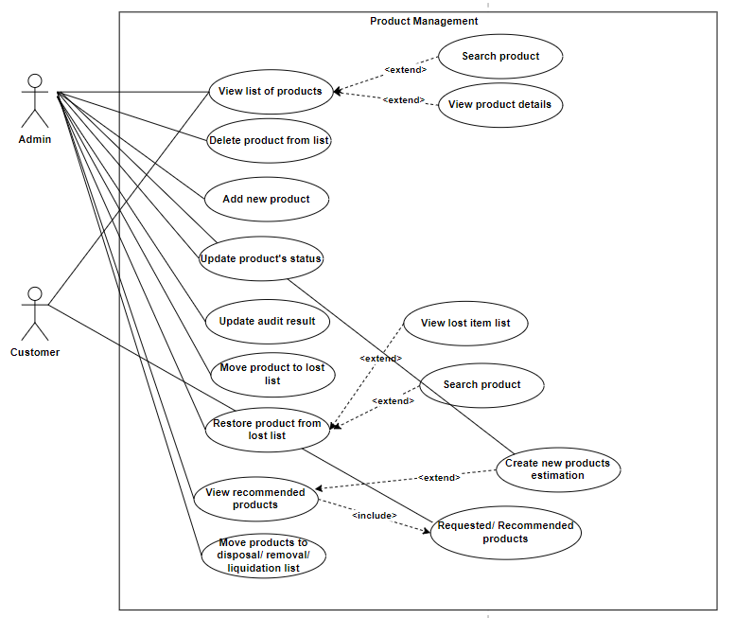
Figure : UC diagram of manage products

# | UC Name | Description
1 | View list of products | This function allows customer & staff to view products
2 | Delete products | This function allows staff delete information of a product
3 | Add new product | This function allows staff add information of a new product
4 | Update product’s status | This function allows staff update status of a product
5 | Update audit result | This function allows staff to upload the result of scheduled audit in which product’s details are updated
6 | Move product to lost list | This function allow staff to update the status of product from available to “lost”
7 | Restore products from lost list | This function allows staff restore products from lost items list
6 | View recommended products | This function allows staff to view the products list that customer request/ recommend
7 | Move products to disposal/ removal/ liquidation list | This function allows staff to update the condition of product in which they are no longer available for usage

2.4.3 Manage report
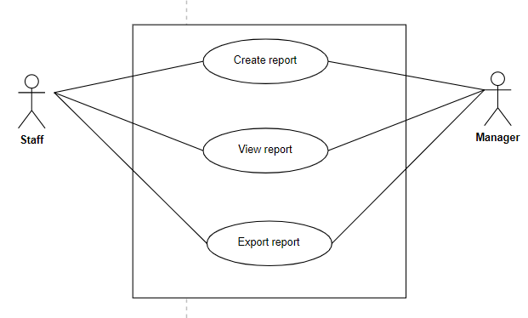
Figure : UC diagram of manage report

# | UC Name | Description
1 | Generate Report | This function allows user to generate report basing on the selected criteria.
2 | View Report | This function allows user to view generated report basing on the selected criteria.
3 | Export Report | This function allows user to export generated report basing on the selected criteria to excel file.

2.5 Permission Matrix
Permission Matrix mapping functions and user roles for Library Management application is described as below:
Remarks:
X | User has permission to do this function with all records.
X* | User has permission to do this function with records pending for him/her or belonging to him/her only.

 | Manager | HR staff | Planning staff | Operation staff | Customer
Module 1: Manage borrow-rent-extend
View list of products | X | X | X | X | X
Create registration card | X |  |  | X | X
Extend time of borrow products | X |  |  | X | X
Update status of a product | X |  |  | X
Check customer’s account status | X |  |  | X | X
Module 2: Manage products
View list of products | X | X | X | X | X
Delete products | X |  |  | X
Add new product | X |  | X | X
Update product’s status | X |  |  | X
Restore products | X |  |  | X
View request of adding products from customers | X |  | X | X
Move products to unused list | X |  |  | X
Module 3: Report management
Create report | X | X | X | X
View report | X | X | X | X
Export report | X | X | X | X

3. Use Case Specifications
This section covers the system’s functional requirements which details what the system must do in terms of input, behavior and the expected output. It elicits the interaction between the actor(s) and the system, the system’s behavior and the results of their interactions.

3.1 General

3.1.1 UC1: Log in

Activity diagram
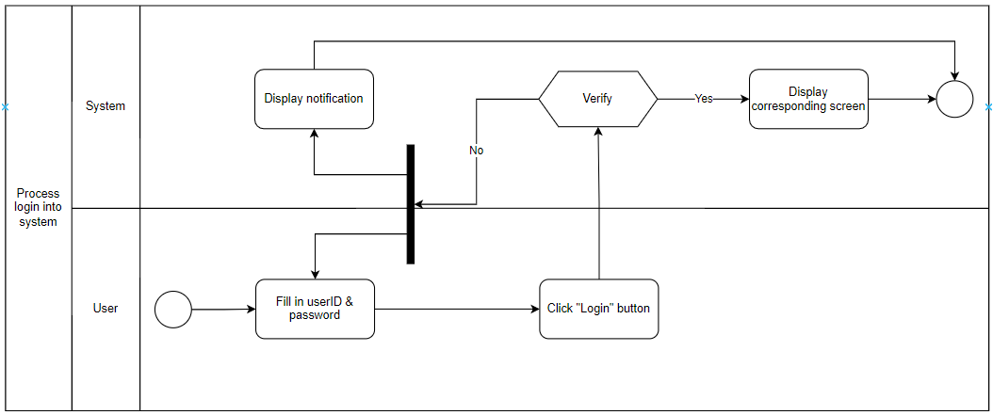

Use case description
Objective: | This function allows the user to login to the system.
Actor: | User
Trigger: | User selects to login on the Login screen.
Pre-condition: | User is not yet logged in to the system.
Post-condition: | User is logged in to the system successfully.

Step | Basic Flow | Exception Flow | Alternative Flow
1 | User fill in ID & password
2 | User clicks “Login” button
3 | System verify login information | 3a. Login information is invalid → System displays failed-in-login notification  3a1. User cancels or fill other information
4 | System display corresponding screen

3.1.2 UC 2: Logout

Activities Diagram
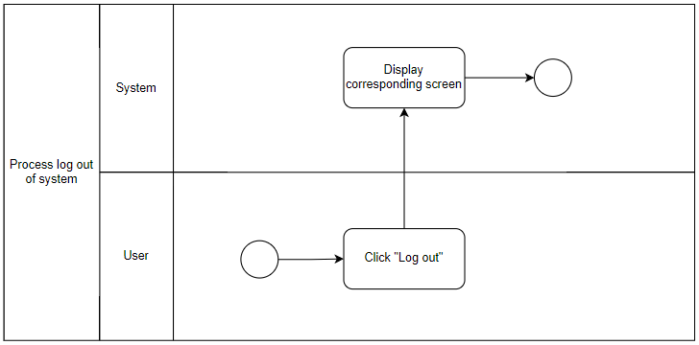

Use case description
Objective: | This function allows the user to logout from the system.
Actor: | User
Trigger: | User selects to logout.
Pre-condition: | User is logged in successfully.
Post-condition: | User is logged out from the system successfully.

Step | Basic Flow | Exception Flow | Alternative Flow
1 | User clicks “Logout” button
2 | System display corresponding screen

3.2 Manage borrow-return-extend products

3.2.1 UC3: Search a product

Activity Diagram
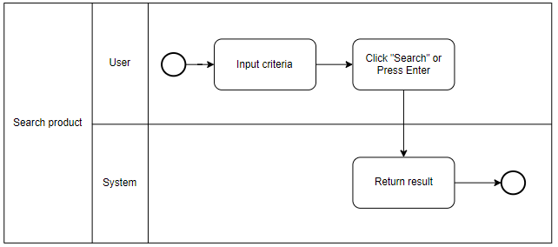

Use case description
Objective: | This function allows the user to search products
Actor: | User
Trigger:
Pre-condition:
Post-condition: | Users get information about the product they are looking for

Step | Basic Flow | Exception Flow | Alternative Flow
1 | Users fill product’s name or select filter conditions to search products
2 | Users click “Search” button or press “Enter”
3 | System display corresponding screen | 3. The product is not found in the system  3a. User click “Request adding products” button  3b. User search other products

3.2.2 UC4: View product information in detail

Activity Diagram
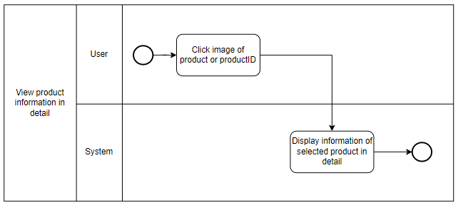

Use case description

Objective: | This function allows the user to view product’s information in detail
Actor: | User
Trigger:
Pre-condition:
Post-condition: | Users get detail information about the product

Step | Basic Flow | Exception Flow | Alternative Flow
1 | Users click on the image of the product or click product name/ID
2 | System display the information of selected product in detail

3.2.4 UC6: Create borrowing card

Activity Diagram
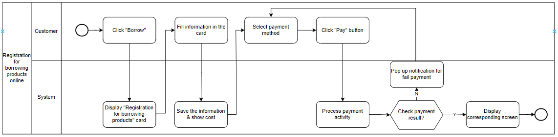

Use case description
Objective: | This function allows customers to borrow products online
Actor: | Customer
Trigger:
Pre-condition: | Customers have an account in the system and log in successfully
Post-condition: | - Customers receive card of borrowing products  - System record the successful registration activity to database

Step | Basic Flow | Exception Flow | Alternative Flow
1 | Customer fill information in registration for borrowing card | 1a. System notify that selected products are sold out  1a1. Customer click “OK” & delete them out of payment list  1a2. Customer move them to waiting list  1a3. Customer choose other products
2 | Customer choose payment method and pay
3 | System verify payment activity | 3a. System confirm unsuccessful payment activity  3a1. Customer choose another payment method  3a2. Customer cancel payment activity
4 | System record successful payment activity
5 | Customer receive notification for successful payment

Use case description
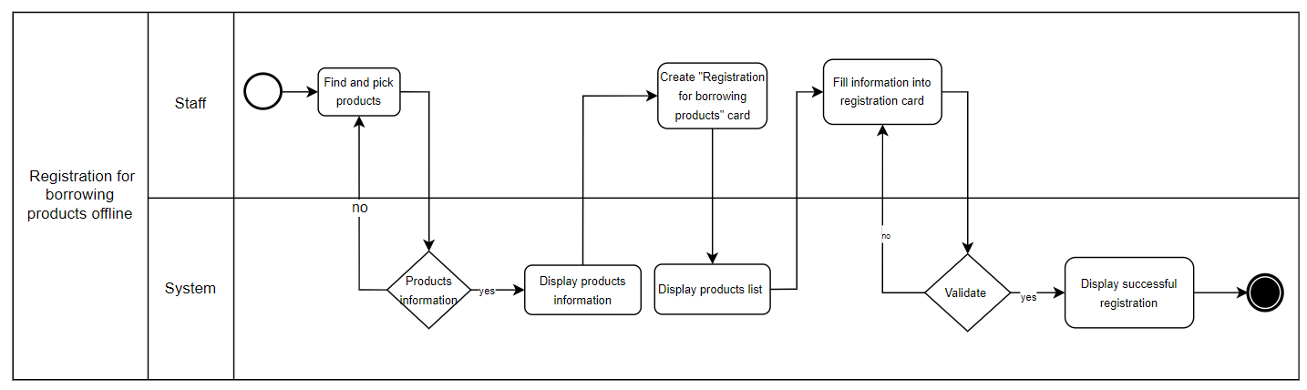
Objective: | This function allows customers to borrow products offline
Actor: | Library staff
Trigger:
Pre-condition: | Staffs have an admin account on the system
Post-condition: | - Customers receive card of borrowing products  - System record the successful registration activity to database

Step | Basic Flow | Exception Flow | Alternative Flow
1 | Staff finds and picks products from products list
2 | System displays products information | 2a. System notices that products aren’t on the list  2b. System notices that products do not have enough quantity
3 | Staff creates “Registration for borrowing products" card”
4 | Staff fills informations into registration card
5 | System validates the registration card | 5.a the registration card is not valid
6 | System confirms the successful registration

3.2.5 UC7: Extend time of borrowing products

Activity Diagram
Extend from customer
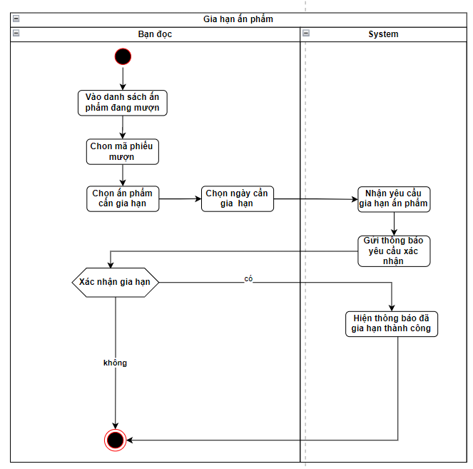

Use case description

Objective: | This function allows customers to extend the borrowed products online
Actor: | Customers
Trigger: | Customers want to extend the borrow time
Pre-condition: | Customers login and select manage borrowed products section.
Post-condition: | - The selected product’s returned date is extended  - System record the successful extended borrowing time

Step | Basic Flow | Exception Flow | Alternative Flow
1 | Customers search/ filter and pick the desired products from borrowed products list
2 | System displays products information/ detail
3 | Customers choose the days to be extended | 4.a. The extended days exceeds the maximum allowed extension.
4 | Systems updates the deadline for return
5 | System confirms the successful extension

Activity Diagram
Extend from Library staff
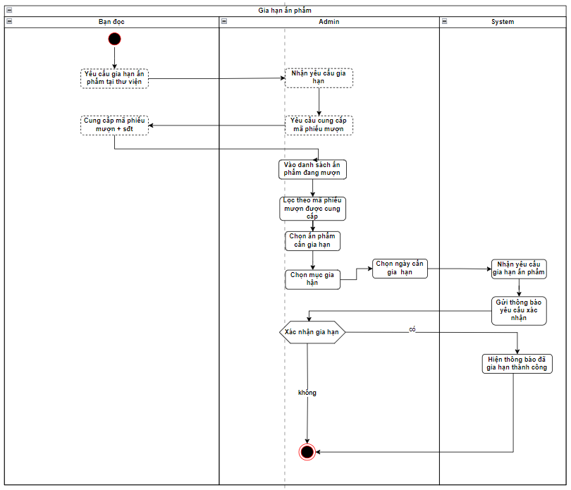

Use case description

Objective: | This function allows Library staff to extend the borrowed products when customer request at the library
Actor: | Library Staff
Trigger: | Customers want to extend the borrow time
Pre-condition: | Library Staff login and select manage borrow-return products section.
Post-condition: | - The selected product’s returned date is extended  - System record the successful extended borrowing time

Step | Basic Flow | Exception Flow | Alternative Flow
1 | Library Staff search/ filter and pick the desired products from borrowed products list
2 | System displays products information/ detail
3 | Library Staff chooses Extend tab
4 | Library staff select the new date for return by edition in the table | 4.a. The extended days exceeds the maximum allowed extension.
5 | Systems updates the deadline for return
6 | System confirms the successful extension

3.2.6 UC8: Delete borrowing card

Activity Diagram
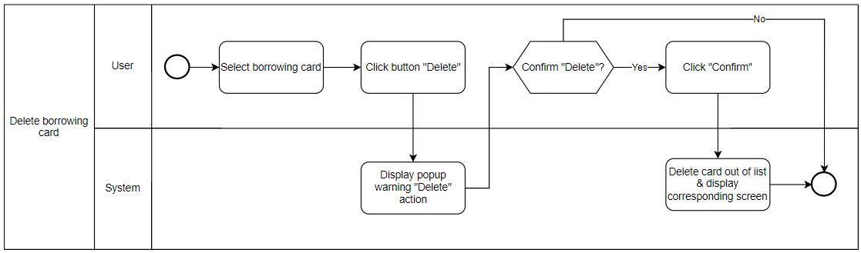

Use case description
Objective: | This function allows customers to delete a borrowing card out of their returned-list
Actor: | Customer
Trigger:
Pre-condition: | Customers borrowed and returned products
Post-condition: | Information of the borrowing card which is selected to delete is not existing in the customer’s list

Step | Basic Flow | Exception Flow | Alternative Flow
1 | Customer selects the borrowing card which they want to delete in returned-list
2 | Click button “Delete”
3 | System display popup warning “Delete” action
4 | Customer click “Confirm” | 4a. Customer click “Cancel”  4a1. System cancel “delete action”
5 | System delete information about the borrowing card out of the customer’s list
6 | System displays notification “Delete successfully”

3.2.7 UC9: Update status of products

Activity Diagram
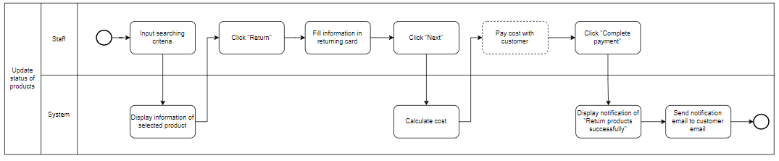

Use case description
Objective: | This function allows staff make returning card
Actor: | Staff
Trigger:
Pre-condition:
Post-condition: | - System records returning action successfully  - Customer receives notification email about returning action

Step | Basic Flow | Exception Flow | Alternative Flow
1 | Staff inputs searching criteria
2 | System displays selected product information
3 | Staff click button “Return”
4 | Staff fill information in the returning card
5 | Staff click “Next”
6 | System calculate cost which will be returned to customers
7 | Staff returned cost to customer
8 | Staff click “Complete payment”
9 | System displays notification popup “Return the product successfully”
10 | System sends notification email to customer

3.2.8 UC: Request add products

Activity Diagram
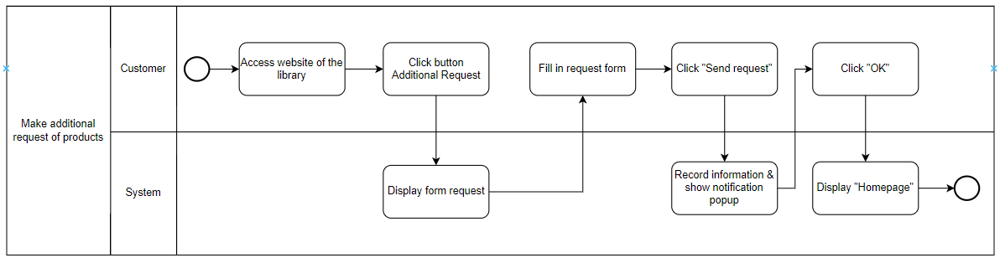

Use case description
Objective: | This function allows customers to request library adding products
Actor: | Customer
Trigger:
Pre-condition:
Post-condition: | System records requests successfully

Step | Basic Flow | Exception Flow | Alternative Flow
1 | Customer accesses to the website of the library
2 | Customer clicks to button “Additional Request”
3 | System displays additional request form
4 | Customer fills in the form
5 | Customer clicks button “Send request”
6 | System records the request
7 | System shows popup “Send request successfully”
8 | Customer clicks “OK”
9 | System displays homepage

3.3 Mange products

3.3.1 UC: Add a new product

Activity Diagram
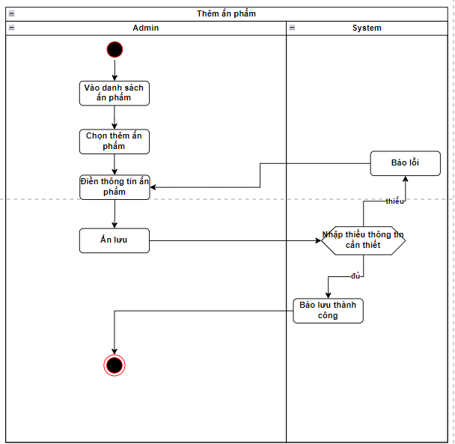

3.3.2 UC: View list of products

Activity Diagram
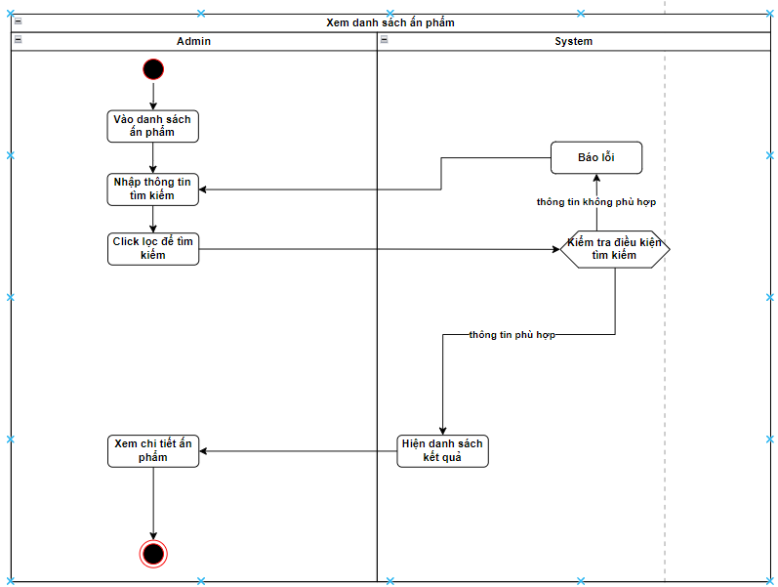

3.3.3 UC: Delete a product

Activity Diagram

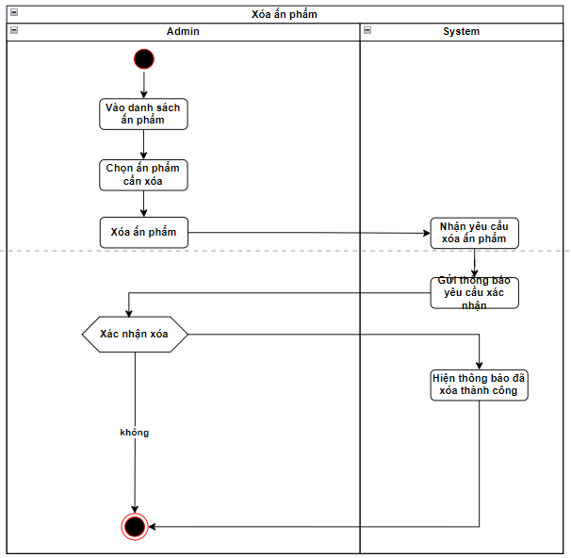

3.3.4 UC: Restore a product from lost item list

Activity Diagram

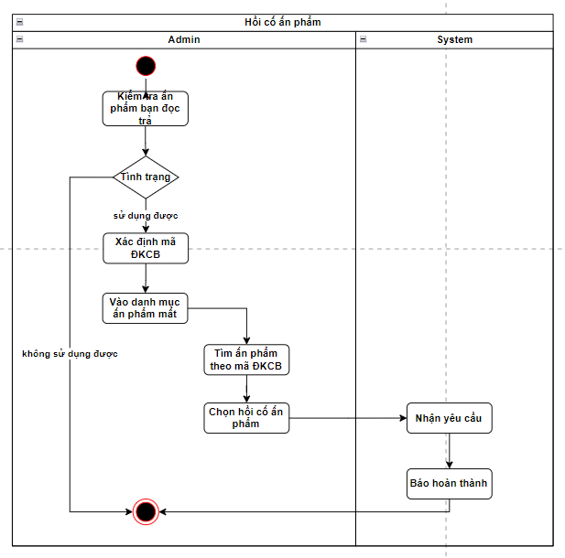

3.3.5 UC: New products estimation (adding new/ recommended products)

Activity Diagram

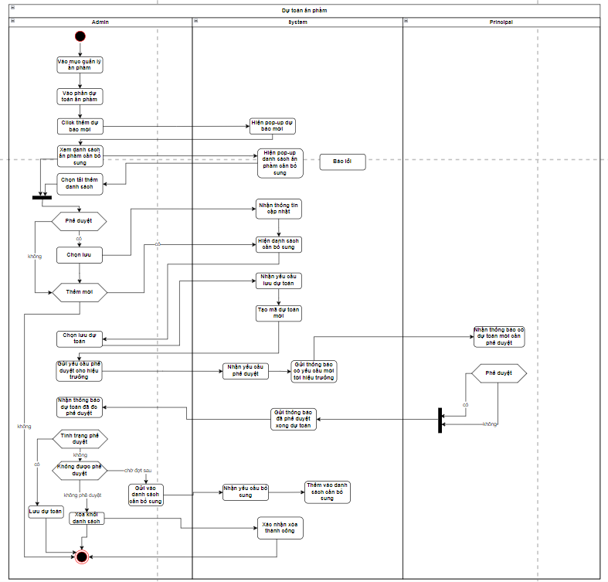

4. Sequence Diagram
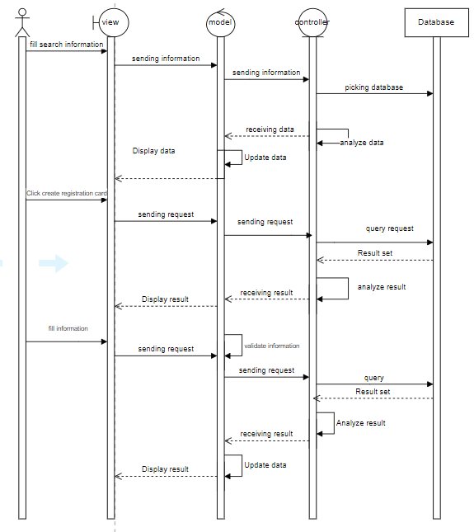

5. Wireframe Screen

5.1 General

5.1.1 Register account
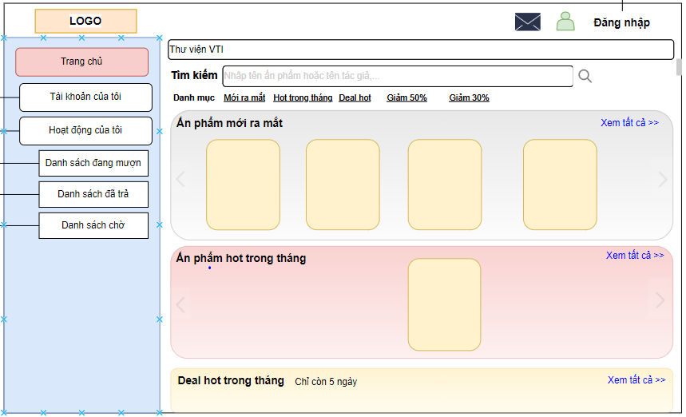
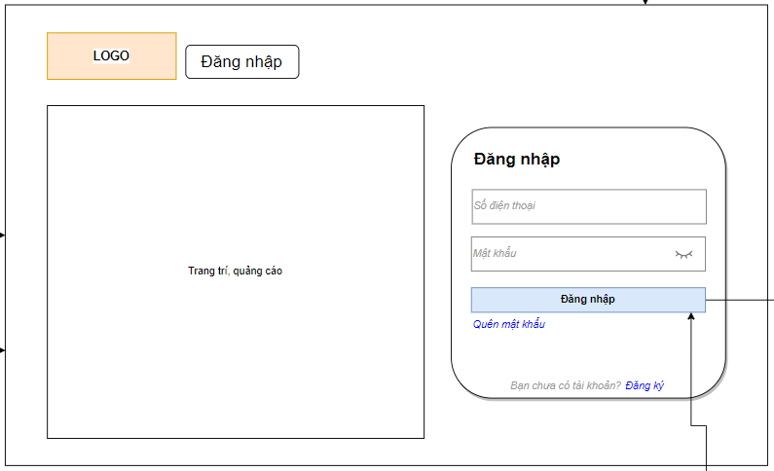
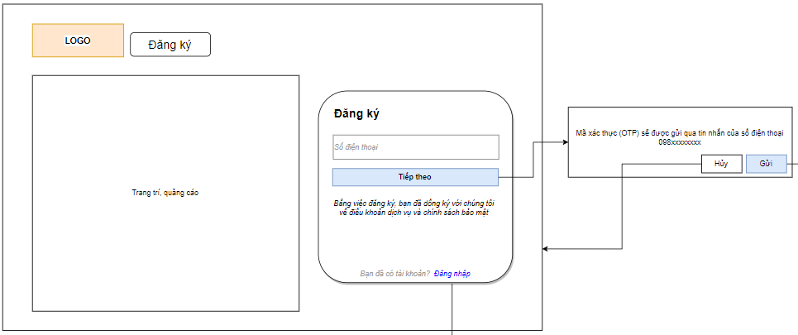
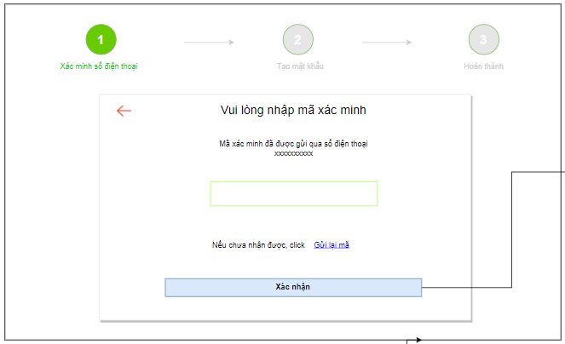
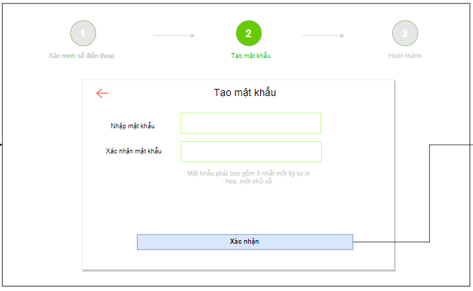
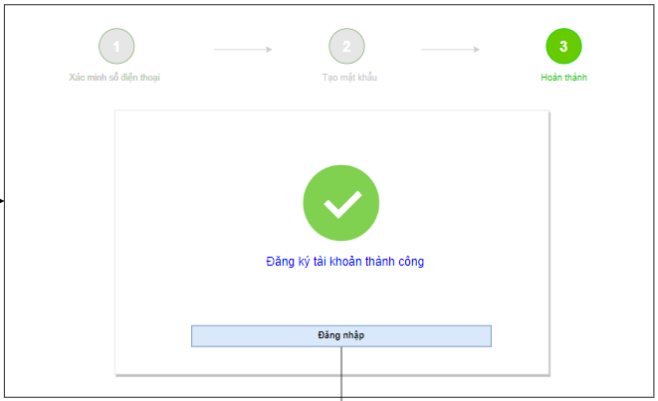

Screen No | Screen Name | Action
1 | Library website without login | Click Đăng nhập
2 | Login screen | Click
3 | Register account | Fill phone number in the block 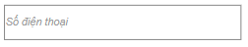
4 | Register account | Click 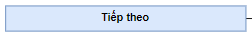
5 | Register account | Click 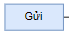 to receive OTP code
6 | Register account | Fill the OTP code in block 
7 | Register account | Fill new password  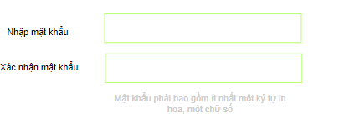
8 | Register account | Click button to confirm new password  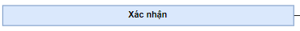
9 | Register account | Click button to return Login screen  

5.1.2 Log in
This screen is for user to log in to System.
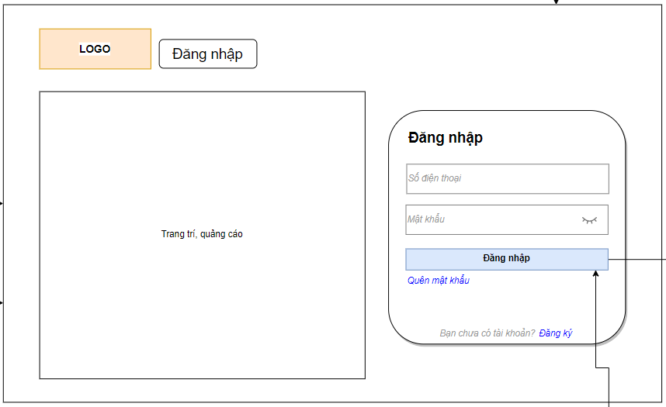
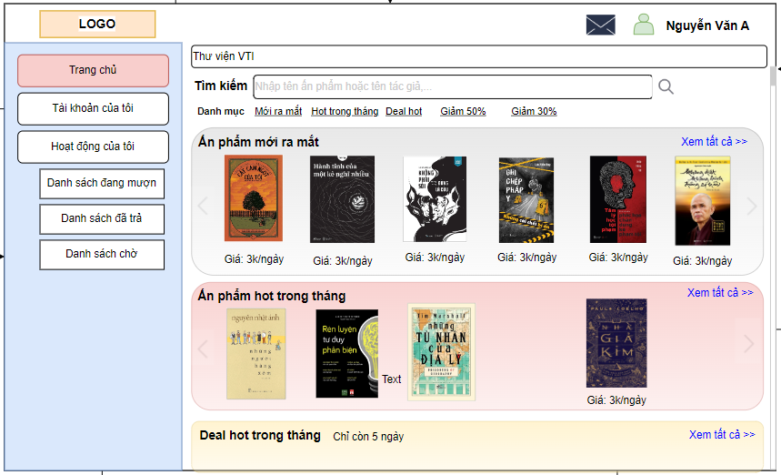

Screen No | Screen Name | Action
1 | Login screen | Fill username & password to login  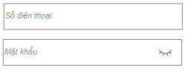
2 | Login screen | Click  

5.2 Manage borrow-return-extend products

5.2.1 Register borrowing products online
This screen displays registration card for borrowing products
In order to access this screen, user has to do the following steps:
- Log in successfully.
- Select products & click “Mượn ngay”
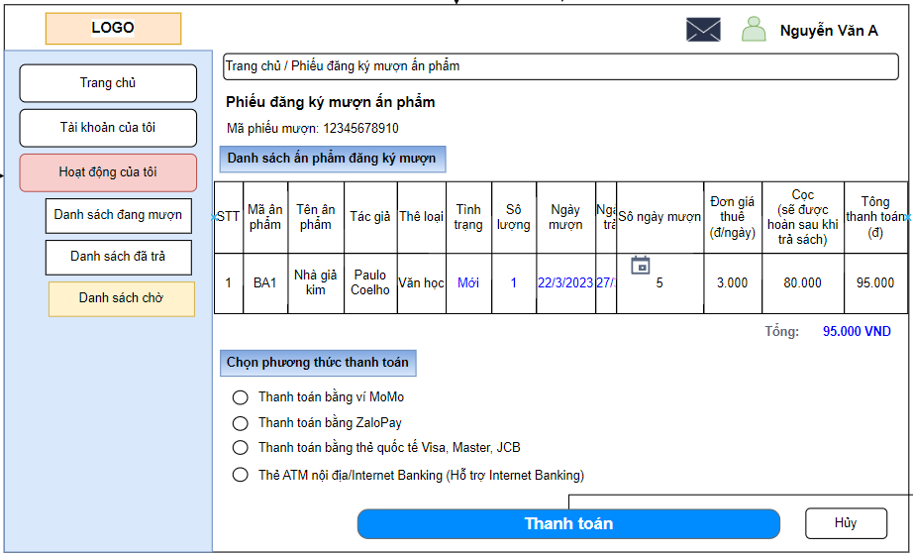

Screen No | Screen Name | Action
1 | Register borrowing books | Choose status of product 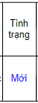
2 | Register borrowing books | Select quantity for borrowing 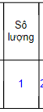
3 | Register borrowing books | Select returning date  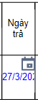
4 | Register borrowing books | Select payment method 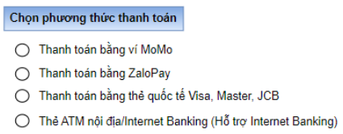
5 | Register borrowing books | Click to pay  

5.2.2 Extend time of borrowing products
This screen is to extend time of borrowing products
In order to access this screen in create mode, user has to do the following steps:
- Log in successfully.
- Click “Danh sách đang mượn”
- Click on “Gia hạn” button
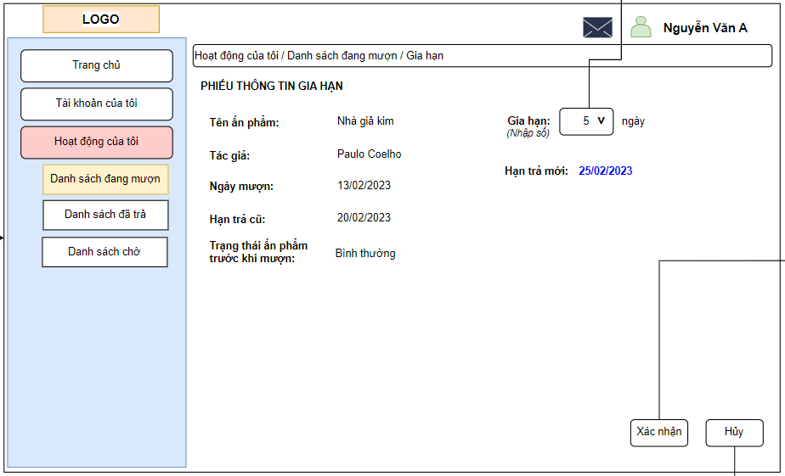

Screen No | Screen Name | Action
1 | Extend time of borrowing books | Choose extend time  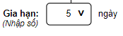
2 | Extend time of borrowing books | Click  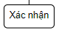

5.2.3 Register borrowing products offline
This screen displays registration card for borrowing products offline
In order to access this screen, user has to do the following steps:
- Log in successfully.
- Select category “Mượn”
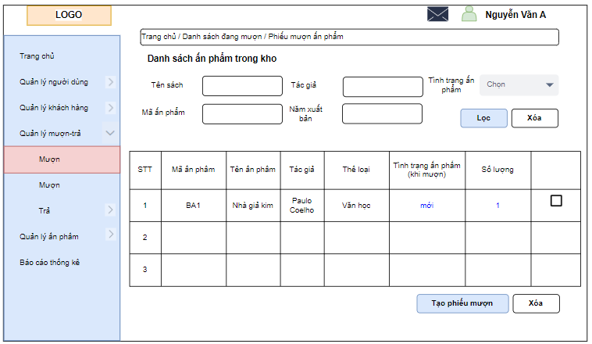
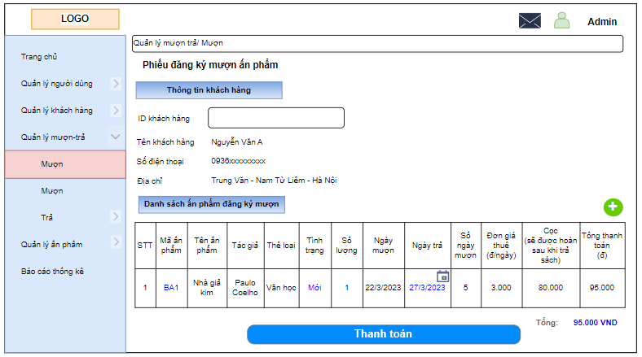
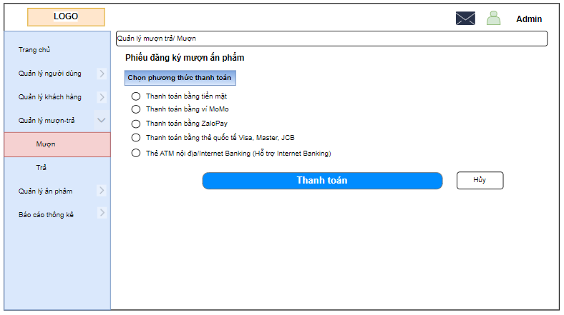
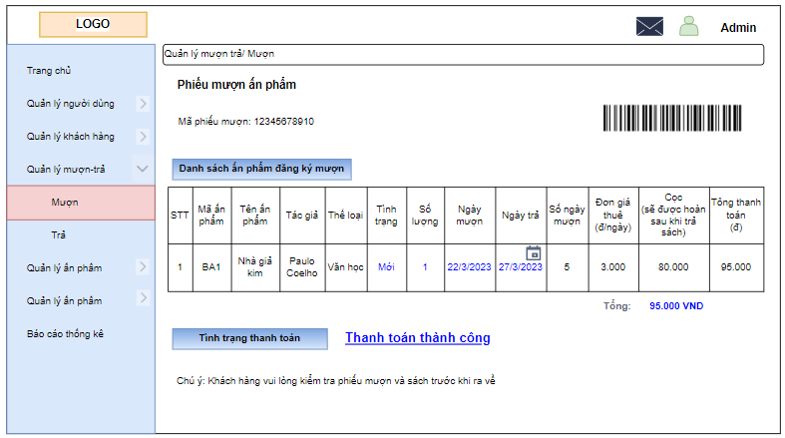

Screen No | Screen Name | Action
1 | Search products | Input criteria and click “Lọc”  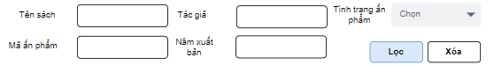
2 | Search products | Tick on checkbox to register for rent 
3 | Search products | Click button  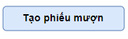
4 | Create registration card | Fill ID of customer
5 | Create registration card | Select status of product  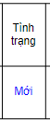
6 | Create registration card | Select time for returning products  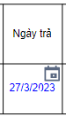
7 | Create registration card | Click button
8 | Payment method | Choose payment method  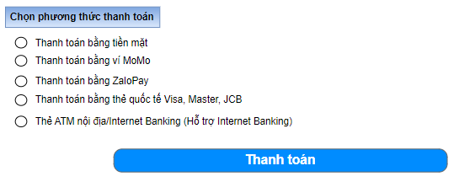

5.2.4 Return product
These screens displays the information relating to returning activities
In order to access the screens, user has to do the following steps:
- Log in successfully.
- Select “Quản lý mượn-trả” → “Trả”
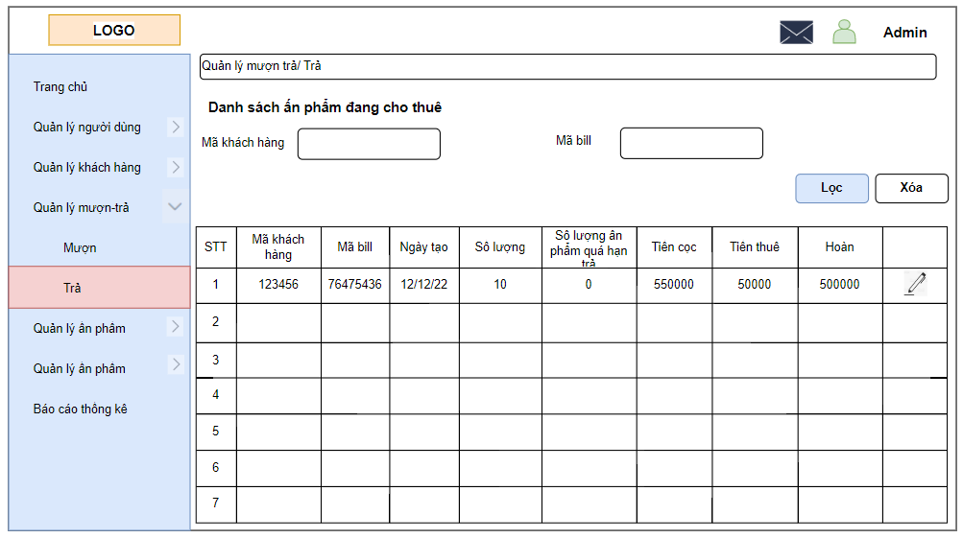

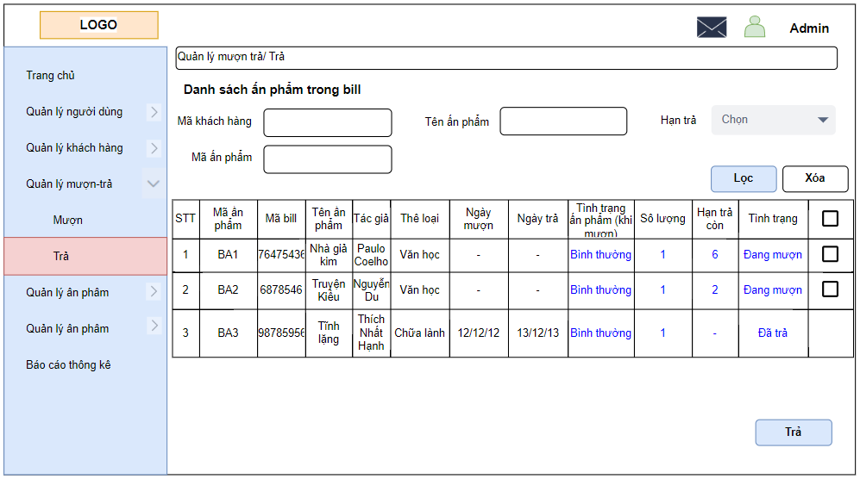
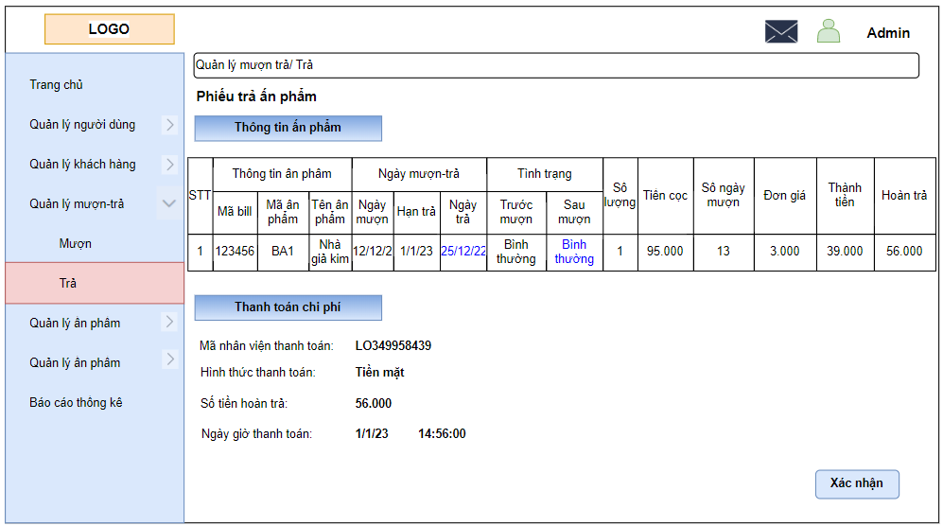
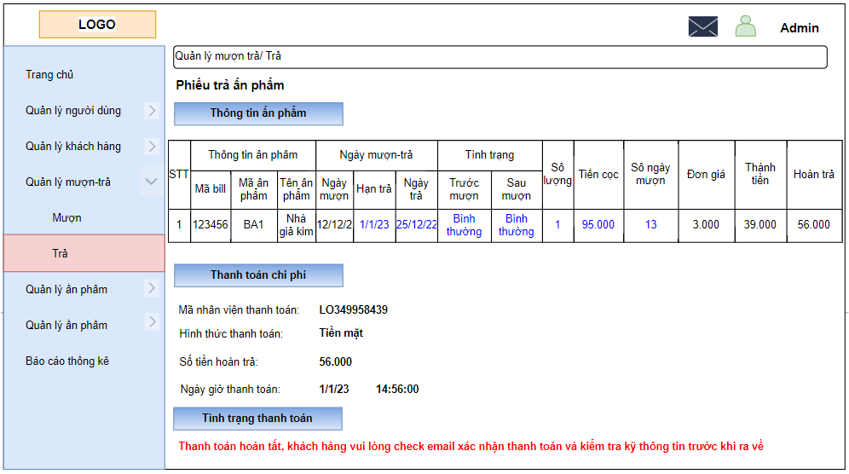

Screen No | Screen Name | Action
1 | Search bill | Input criteria and click “Lọc”  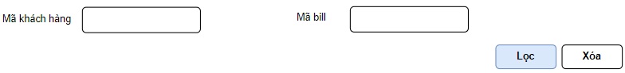
2 | Search bill | Click button to conduct returning action
3 | Rented products in a bill | Select the product needed to return in checkbox 
4 | Rented products in a bill | Click to conduct payment
5 | Payment | Fill information 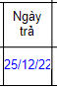 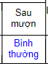
6 | Payment | Check information & click 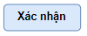

5.3 Manage products

5.3.1 View products
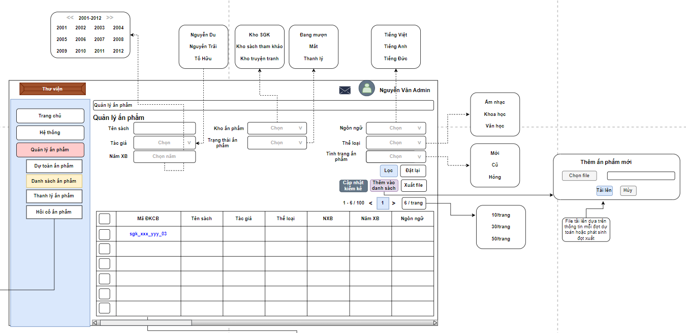

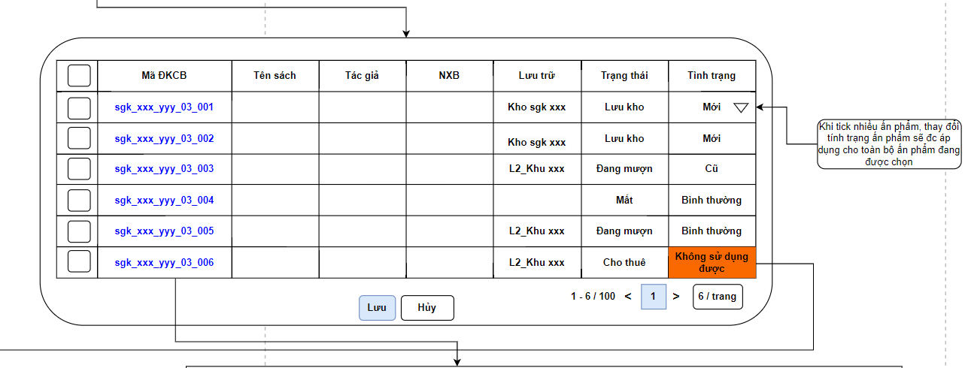
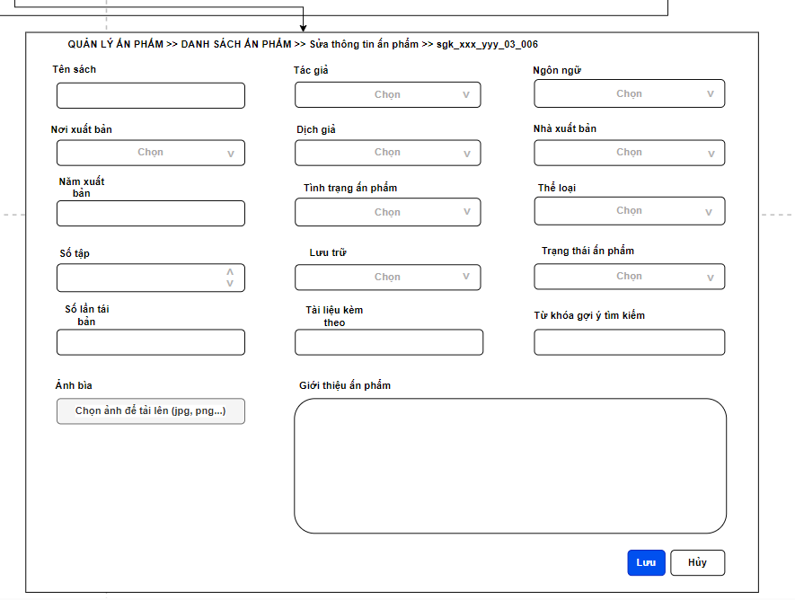

5.3.2 Restore products from lost items list

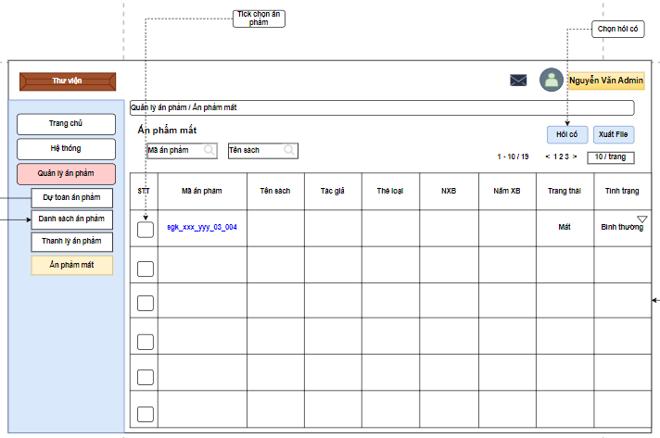

5.3.3 Dispose/ Liquidate/ Remove Products

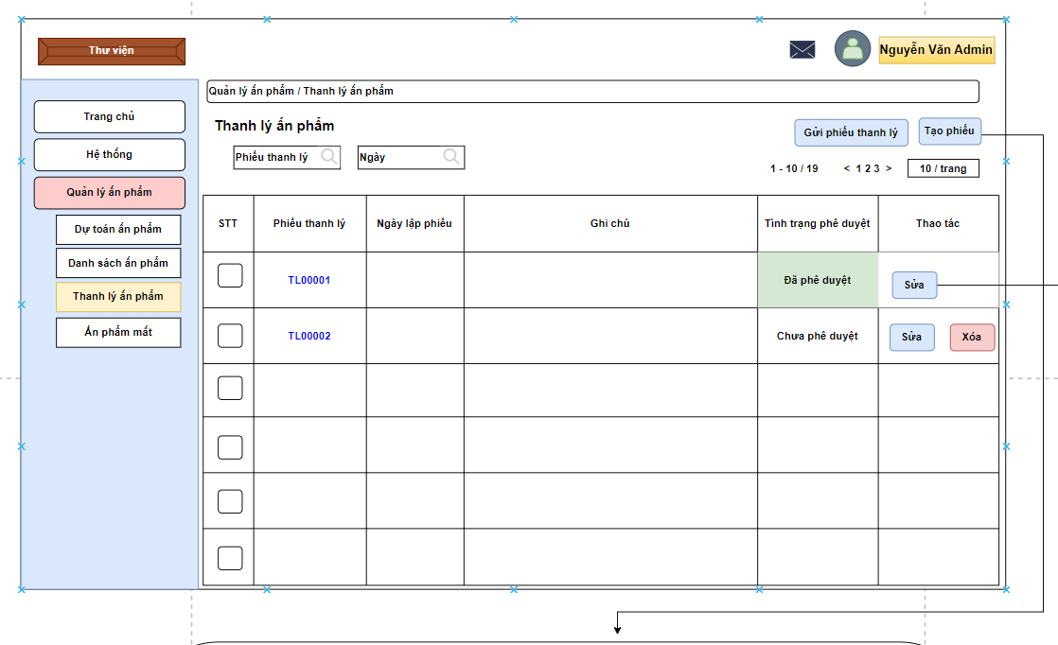
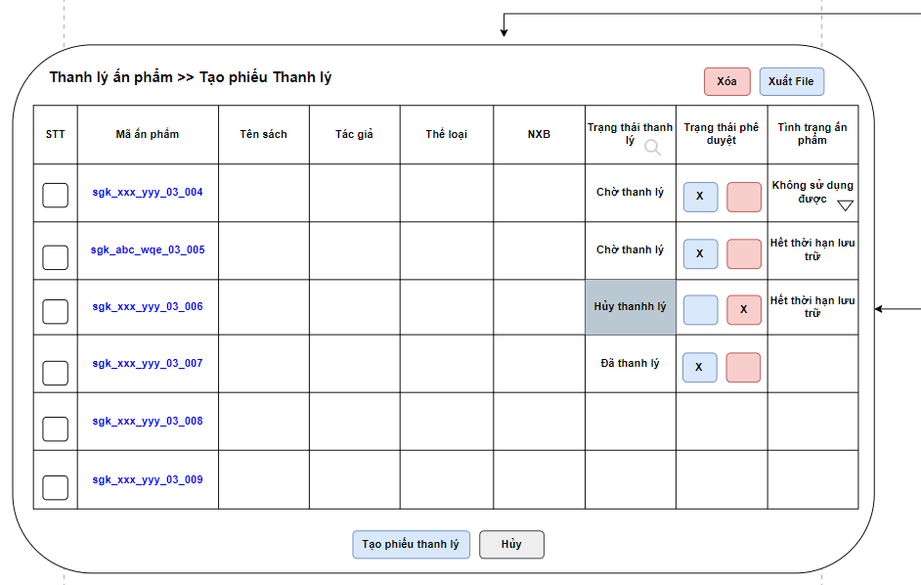

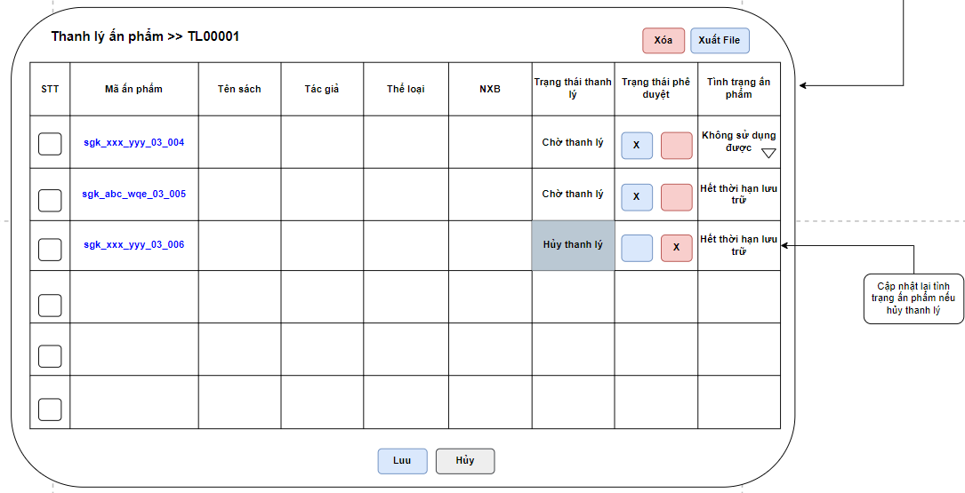
Figure: View Removal Notes after Principal’s Approval

5.3.4 New products estimation (adding new/ recommended products) - Library staff/ Admin

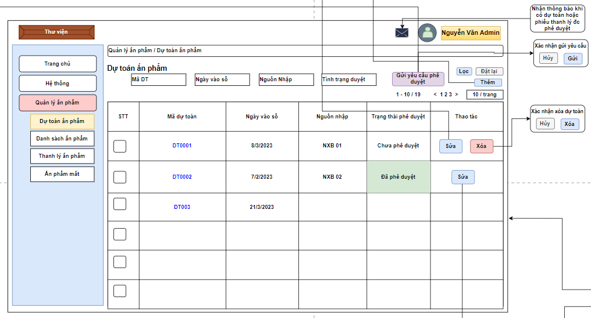
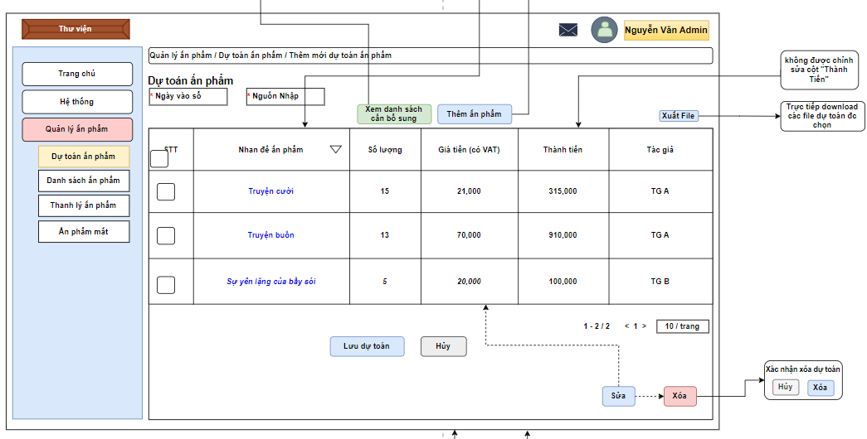
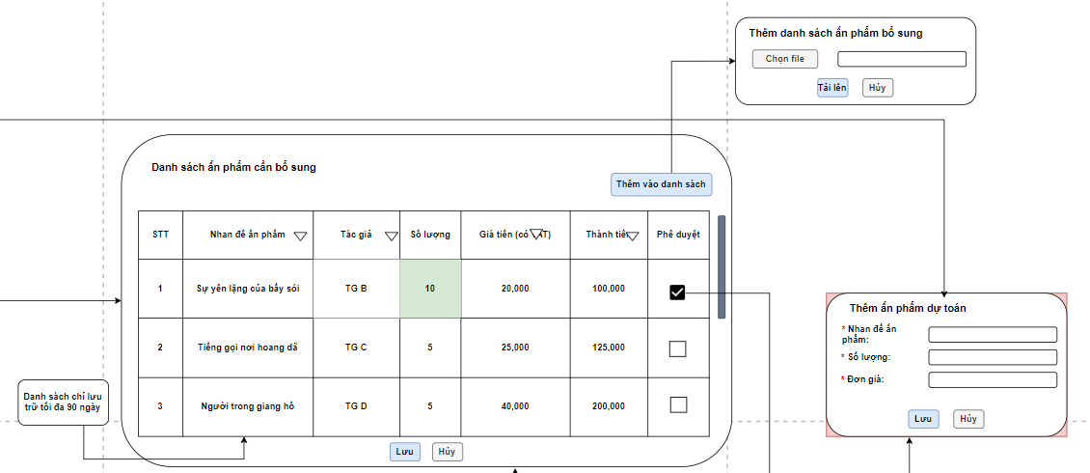
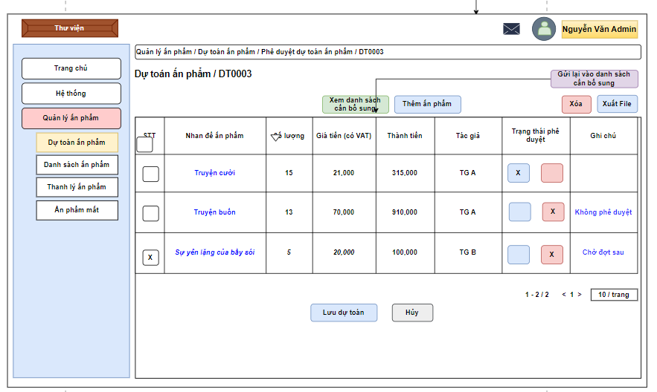

5.3.5 New products estimation (adding new/ recommended products) - Library staff/ Admin

